Get .gitignore from

<https://github.com/aspnet/Docs/blob/master/.gitignore>

edit .gitignore

remove

project.lock.json

**/sample/**/wwwroot/lib/

**/samples/**/wwwroot/lib/

__pycache__/

<https://stackoverflow.com/questions/44223427/gitignore-still-including-asp-net-core-wwwroot-lib-directory>

edit .gitignore

add these lines to file

project.lock.json

**/wwwroot/lib/

**/wwwroot/js/

**/wwwroot/css/

**Do the above before publish to github**

Remove .git directory

Open vs20127

Goto connections

Remove old repo if you are reding to a new repo

Select Connections

Right click select remove

**You may have to enter your github credentials**

Select sync

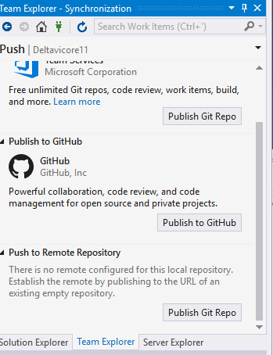

Click publish to github

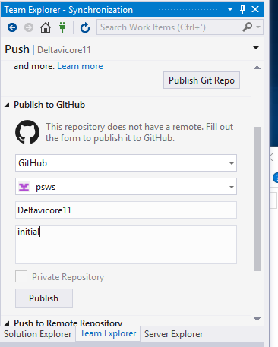

Click Publish

This creates repo with your sln name on github

Also creates .git local repo